Project 10-4: Using Microsoft Windows Netsh Commands
Estimated time: 30 minutes
Objective: Use the Windows netsh feature.
Description: Microsoft Windows displays the network status of a device that is connected to a network, either a wired network or a Wi-Fi network. However, configuring different connection parameters is largely unavailable to users through the main interface. The Windows Network Shell (netsh) can be used to configure and display advanced network settings. Netsh is a command-line interface (CLI) that requires commands to be typed instead of selected from a menu. This gives netsh extended flexibility. In this project, you will explore some of the netsh commands.

Note: For this project, you will need a computer running Microsoft Windows that has a wireless NIC and can access a Wi-Fi network.

- In Microsoft Windows, right-click the Start button.
- Select Terminal (Admin). This will open the Windows command window in elevated privilege mode.
- Type netsh and then press Enter. The command prompt will change to netsh>.
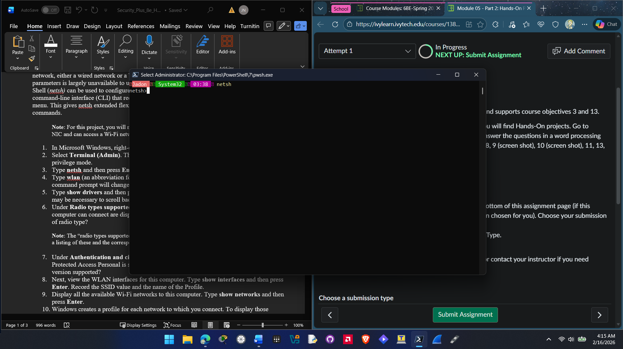

- Type wlan (an abbreviation for wireless local area network) and then press Enter. The command prompt will change to netsh wlan>.

- Type show drivers and then press Enter to display the wireless adapter information. It may be necessary to scroll back toward the top to see all the information.
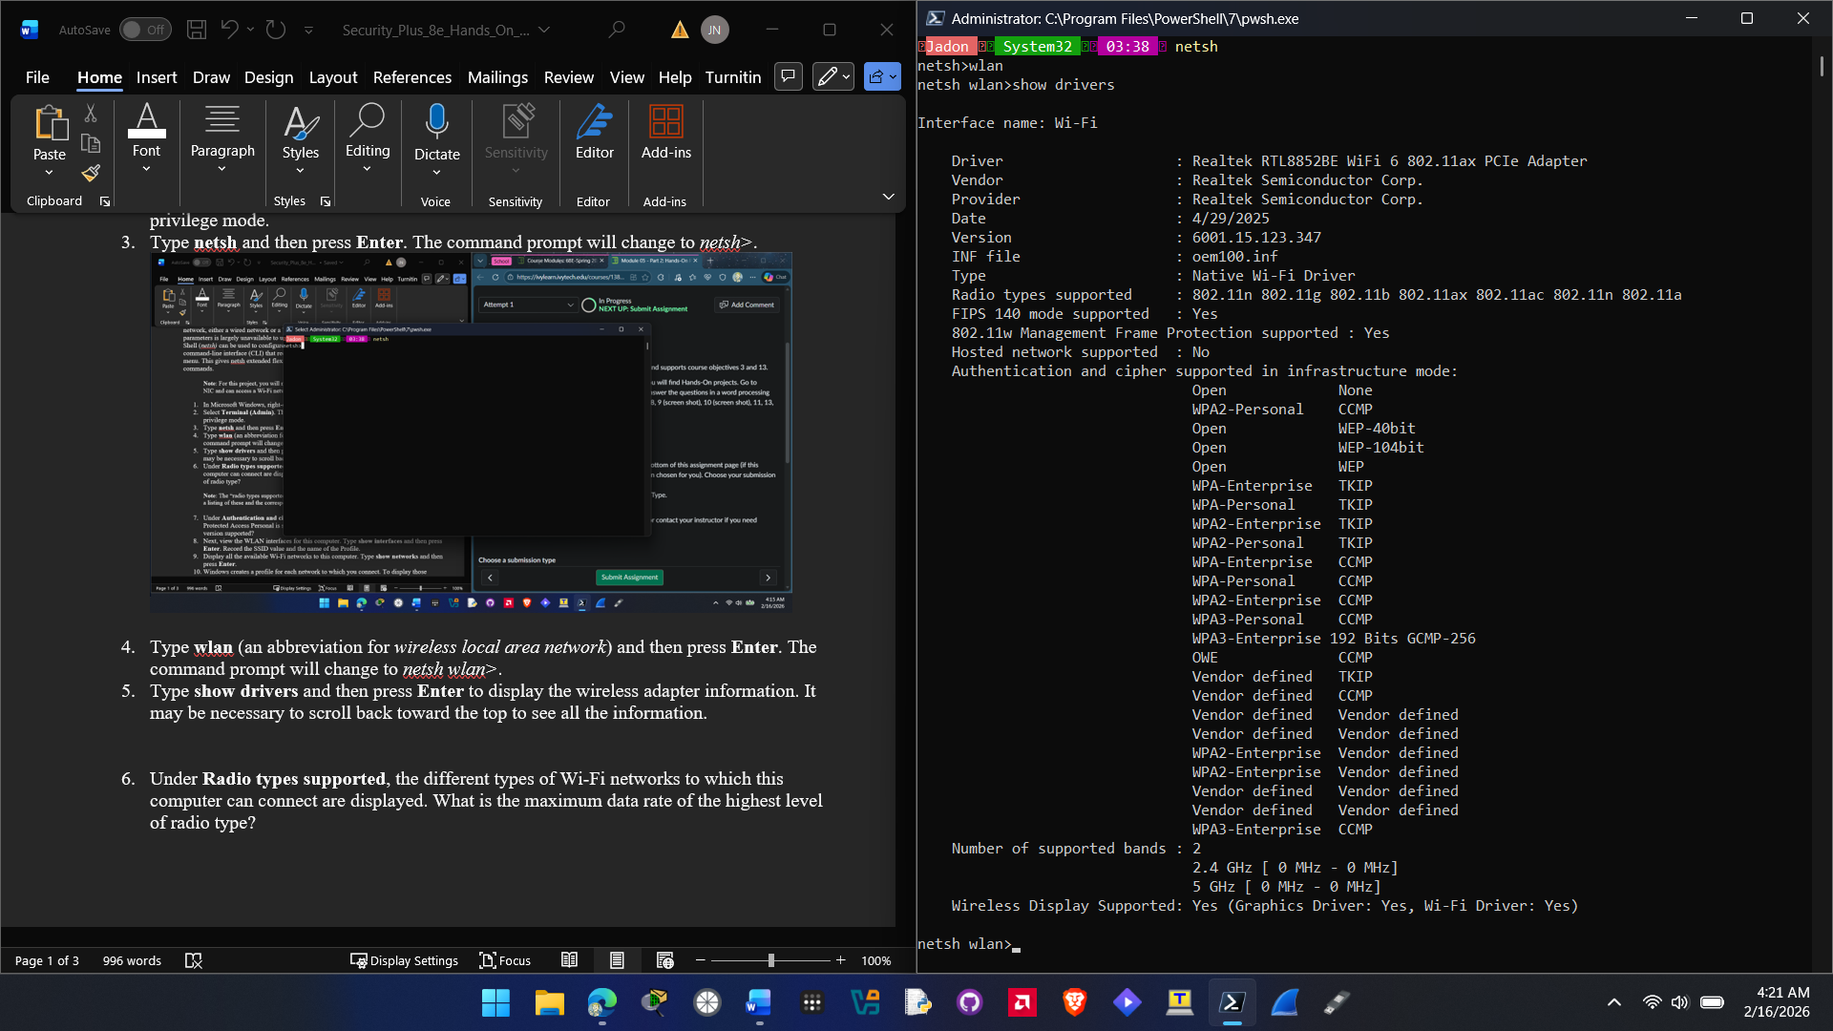

- Under Radio types supported, the different types of Wi-Fi networks to which this computer can connect are displayed. What is the maximum data rate of the highest level of radio type?
802.11ax

Note: The “radio types supported” are listed by their IEEE nomenclature. Refer to Table 10-4 for a listing of these and the corresponding Wi-Fi Alliance versions.]

- Under Authentication and cipher supported in infrastructure mode, which Wi-Fi Protected Access Personal is supported, WPA2 Personal or WPA3 Personal? Why is this version supported?
Both WPA2 Personal and WPA3 Personal are supported. They are both secure versions of authentication with different use cases so they are both supported.

- Next, view the WLAN interfaces for this computer. Type show interfaces and then press Enter. Record the SSID value and the name of the Profile.
SSID value: Kokokoz3.0
Profile: Kokokoz3.0

- Display all the available Wi-Fi networks to this computer. Type show networks and then press Enter.
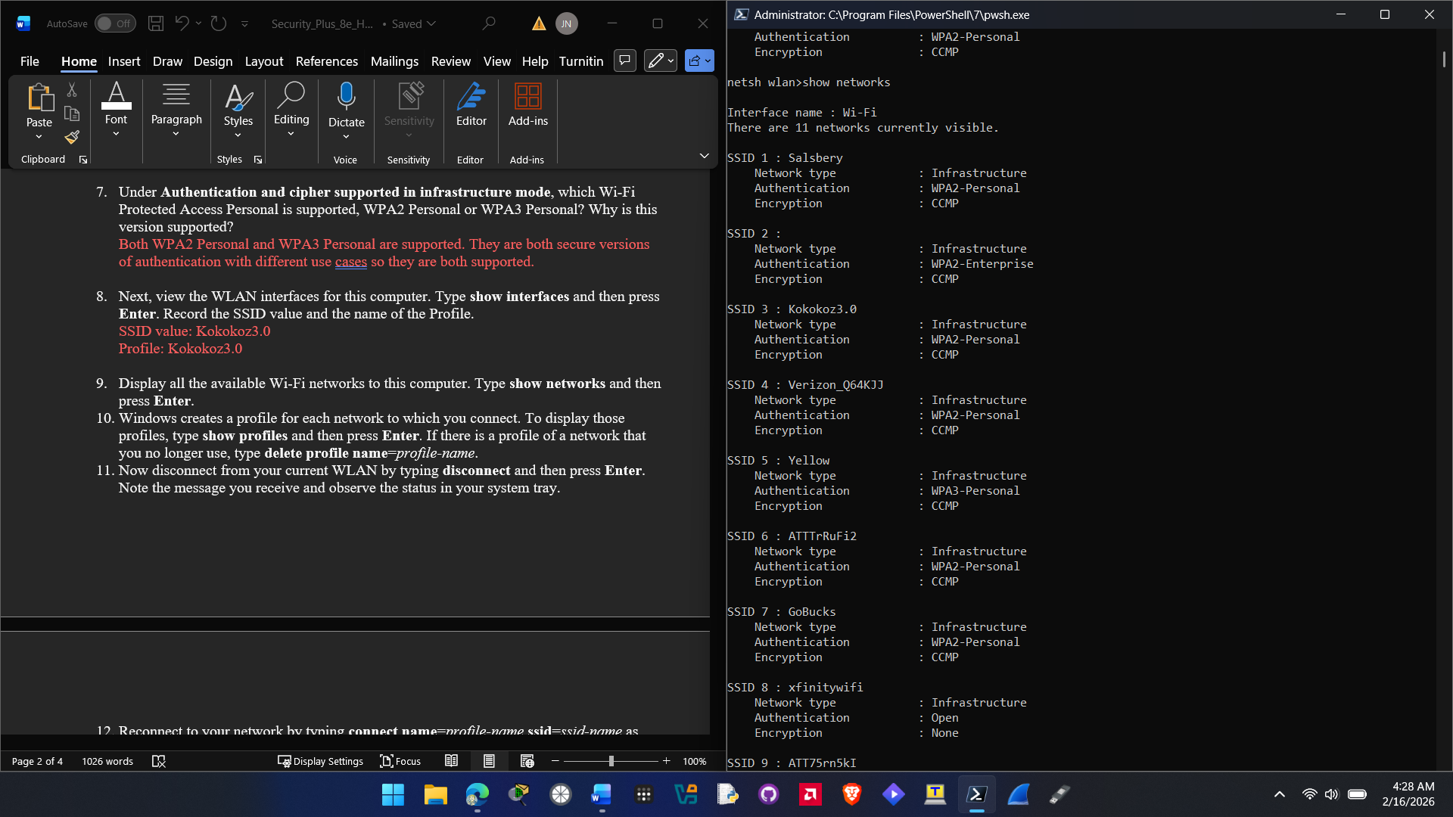

- Windows creates a profile for each network to which you connect. To display those profiles, type show profiles and then press Enter. If there is a profile of a network that you no longer use, type delete profile name=profile-name.
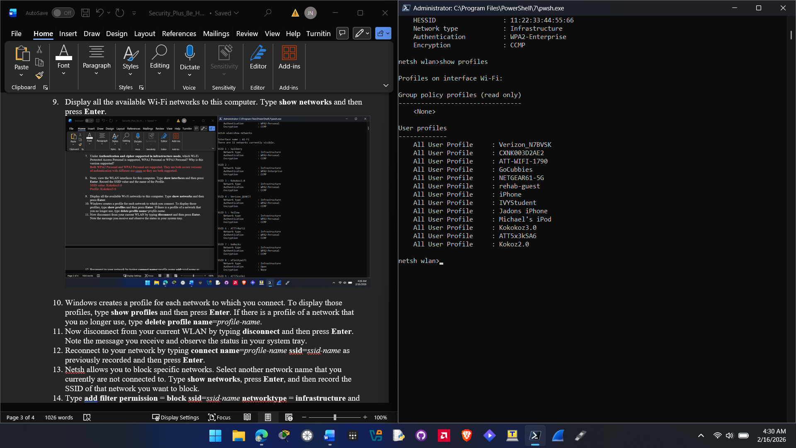

- Now disconnect from your current WLAN by typing disconnect and then press Enter. Note the message you receive and observe the status in your system tray.
The message I received was disconnection request was completed successfully for interface “Wi-Fi”. And in the system tray it disconnected from my wireless network.
- Reconnect to your network by typing connect name=profile-name ssid=ssid-name as previously recorded and then press Enter.
- Netsh allows you to block specific networks. Select another network name that you currently are not connected to. Type show networks, press Enter, and then record the SSID of that network you want to block.
SSID: GoBucks

- Type add filter permission = block ssid=ssid-name networktype = infrastructure and then press Enter.
- Type show networks and then press Enter. Does the network that you previously blocked appear in the list?
No the network GoBucks that I blocked does not show up on the new list.

- Now display the blocked network (but do not allow access to it). Type set blockednetworks display=show and then press Enter.
- Type show networks and then press Enter. Does the network that you previously blocked appear in the list?
Yes the network appears again on the list of SSIDs
- Click the wireless icon in your system tray. Does the network appear in this list?
Yes the network appears in the wireless icon in the system tray

- Click the wireless icon in your system tray again. What appears next to the name of this blocked network?
A huge x symbol appears next to this blocked network.

- Now re-enable access to the blocked network by typing delete filter permission = block ssid=ssid-name networktype = infrastructure and then press Enter.
- Netsh can also generate a detailed Wi-Fi network report. This report shows all the Wi-Fi events from the last three days and groups them by Wi-Fi connection sessions. It also shows the results of several network-related command line scripts and a list of all the wireless adapters. Type show wlanreport and then press Enter.
- Record the location to which the report was written.
C:\ProgramData\Microsoft\Windows\WlanReport\wlan-report-latest.html

- Open a web browser and type the location of the report. For example, if the location is C:\ProgramData\Microsoft\Windows\WlanReport\wlan-report-latest.html then enter into the web browser file:/// C:\ProgramData\Microsoft\Windows\WlanReport\wlan-report-latest.html.
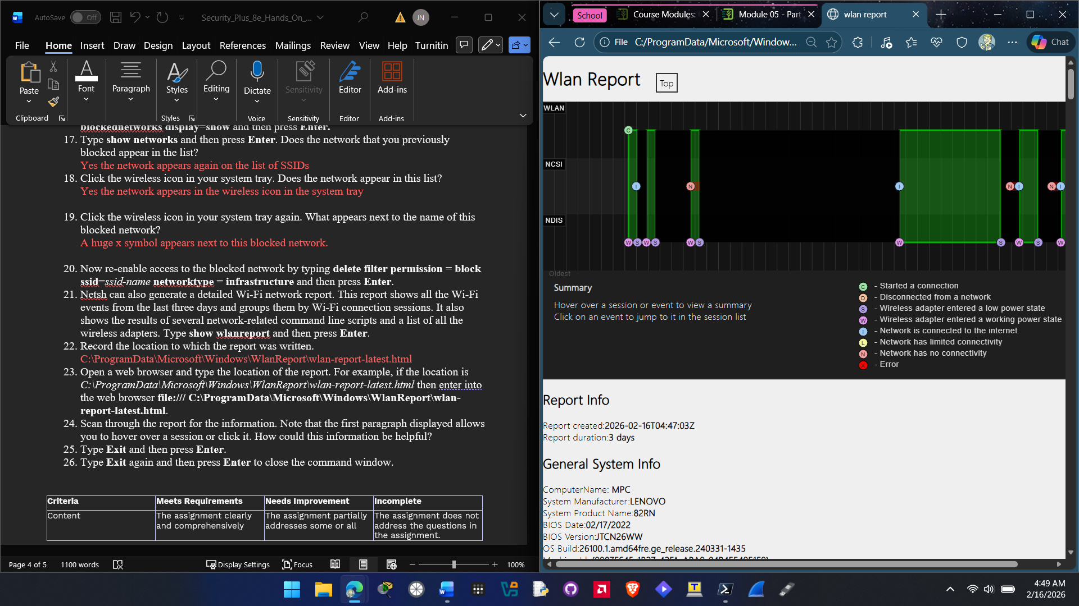
- Scan through the report for the information. Note that the first paragraph displayed allows you to hover over a session or click it. How could this information be helpful?
This information can be helpful by giving you connection events and how long a client stayed connected to a specific network.

- Type Exit and then press Enter.
- Type Exit again and then press Enter to close the command window.

Criteria | Meets Requirements | Needs Improvement | Incomplete
Content | The assignment clearly and comprehensively addresses all questions in the assignment.  15 points | The assignment partially addresses some or all questions in the assignment.  8 points | The assignment does not address the questions in the assignment.  0 points
Organization and Clarity | The assignment presents ideas in a clear manner and with strong organizational structure. The assignment includes appropriate content, coverage of facts, arguments, and conclusions.  10 points | The assignment presents ideas in a mostly clear manner and with some organizational structure. The assignment includes appropriate content, coverage of facts, arguments, and conclusions.  7 points | The assignment does not present ideas in a clear manner or with a strong organizational structure. The assignment includes some appropriate content, but coverage of facts, arguments, and conclusions are not logically related and consistent.  0 points
Research | The assignment is based upon appropriate and adequate data collection and analysis of results from the activity or research from academically reliable sources.  5 points | The assignment is based upon adequate data collection and includes some analysis of results from the activity or research from academically reliable sources.  3 points | The assignment is not based upon appropriate data collection and includes no analysis of results from the activity or research from academically reliable sources.  0 points
Grammar and Spelling | The assignment has two or fewer grammatical and spelling errors.  5 points | The assignment has three to five grammatical and spelling errors.  3 points | The assignment has more than five grammatical and spelling errors, is incomplete, or is unintelligible.  0 points

